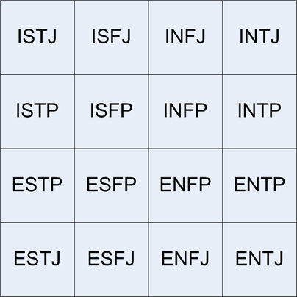

Personal Product Assessment and Analysis
Marketing 300 section 7
Submission Date: October 4th, 2012
Student number: 573283
Student e-mail: kcsanders@bsu.edu

Executive summary:
This personal Product assessment and analysis determines and analyses my personality, skills, values, and interests. This is important for my future life in the work place and in future relationships. This first section of our project includes 10 different tests, and feedback from my employers and teammates.

Table of contents

Personal mission statement 3

Assessments:

The Keirsey temperament solver 4

Basic personality test 5

Ambition test 6

Concentration and focus skills test 6

Myers-Briggs Type Indicator 8

Strengthsfinder 2.0 14

Sigi3 17

PersonalDNA test 20

Big Five Personality test 23

41 questions, 1 personality test 24

Feedback from employers 26

Survey with team members 27

Conclusion 30

Bibliography 31

Personal mission statement

I am serious, hard working, and trustworthy. I want to use my intelligence and dedication to do well in school and my career, and I want to keep improving myself at the tennis court. Whatever I am doing, I accomplish with orderliness and reliability. I want people to be able to trust me and believe in me, and it is important for me how people think of me. Some things I could still improve in are: being able to handle change, and feeling more confident about things I that are new to me. Next to all this, I want to be there for my family and everyone at home.

The Keirsey Temperament Sorter

This is the most widely used personality assessment in the world. On the basis of 70 questions, this test helps individuals determine their personality type. According to Keirsey Temperament Theory, there are four basic temperament groups, which describe human behavior. Keirsey’s four temperaments are referred to as Artisans, Guardians, Rationals, and Idealists. These four temperaments can be further subdivided, often referred to as “Character Types”. There are four types of Artisans, four types of Guardians, four types of Rationals, and four types of Idealists (see figure below).

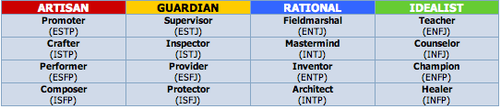

Results:
After taking the test, the results indicated that I am a Guardian Inspector (ISTJ).
Description of a Guardian Inspector:
The one word that best describes Inspectors is superdependable. Whether at home or at work, Inspectors are extraordinarily persevering and dutiful, particularly when it comes to keeping an eye on the people and products they are responsible for. In their quiet way, Inspectors see to it that rules are followed, laws are respected, and standards are upheld.
Just like the Myers-Briggs Type Indicator, this test also indicated that I am a type ISTJ. This means that both tests were accurate, and the personality traits that come with this personality type are that Guardian Inspectors want to make sure that schedules are made and followed, and these people know their duties.

Basic personality test

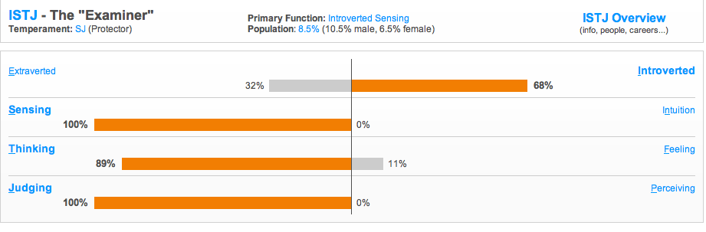
The basic personality test is a test that asks different questions, and lets you chose between two possible answers. There are 67 questions total, and they determine your personality type in a similar way the Myers-Briggs Type Indicator does. My results are shown in the figure above, and the results correspond to my results in the MBTI test. Both test indicate that I am a type ISTJ: Introverted, Sensing, Thinking, and Judging.
Explanation of the “Examiner”: ISTJs are responsible, loyal and hard working. They have an acute sense of right and wrong and work hard at preserving established norms and traditions. Because of their deep sense of duty they are dedicated to everything they do and are very dependable. ISTJs care deeply for those closest to them. These characteristics fit me well, because I think I am very responsible and I always work hard for everything I do.

Ambition test
This ambition test measures my level of ambition in 34 statements that had to be answered in how much the statement fits me. Ambition is important in personal and professional life.
Result:
73/100
Your current family environment (or the environment you grew up in) provides a fair amount of support of your aspirations. Your parents often encourage you to reach your full potential and while this may have had an impact on your level of ambition, it's important to keep in mind that how high far and how high you go in life is ultimately your choice. The support of those close to you can be helpful, but you must also build and use your own inner strength and motivation, especially if, in spite of the encouragement you receive, you still haven't reached your goals.
This is true, my family supports me in everything I do and help me in getting the best out of myself. But next to all my family support, I also motivate myself and have a lot of ambition. I want to be the best in everything I do, but also accept defeat.

Concentration and focus skills test
The ability to concentrate takes some people a lot of effort. It can be really hard to stay focused when there is too much background noise or when you are just plain bored. However, with practice, a little willpower and a few clever strategies, there are ways to stay focused. This concentration and focus skills test measured how good I am at focusing at my goals and assignments by making me chose how much each of the 21 statements fits me.
Result:
78/100
Your results indicate that you use many strategies to help you concentrate. You may have a little difficulty getting started on and completing tasks on the rare occasion, but for the most, you know what to do to help you stay focused. Although this does require a certain act of will, there are ways to keep your mind on track and lessen the tendency to daydream. It is likely that you do use many of tactics, but may need to add to your repertoire. Keep in mind that they can not only help increase your concentration span, but also make it less likely that you will get bored, frustrated, or distracted.
People generally know me as a person that concentrates well, and want to get her tasks done. Everyone has a hard time focusing sometimes, especially when I am tired it takes me more effort, but because I always want to reach my goals I find ways to concentrate myself.

Myers-Briggs Type Indicator
The Myers-Briggs Type Indicator is a personality assessment that, based of responses to 70 questions, develops the person’s preference on four dichotomies;
- Extravert – Introvert
- Sensing – Intuition
- Thinking – Feeling
- Judging – Perceptive
After taking the test, the Myers-Briggs Type Indicator then gives the person a four-letter description of the personality type. These four letters indicate the kind of person they are, what their strengths and weaknesses are, and how they might handle certain kinds of situation. The MBTI also gives appropriate careers for that certain personality type.
My type is ISTJ, which means introvert, sensing, thinking, and judging (see picture).
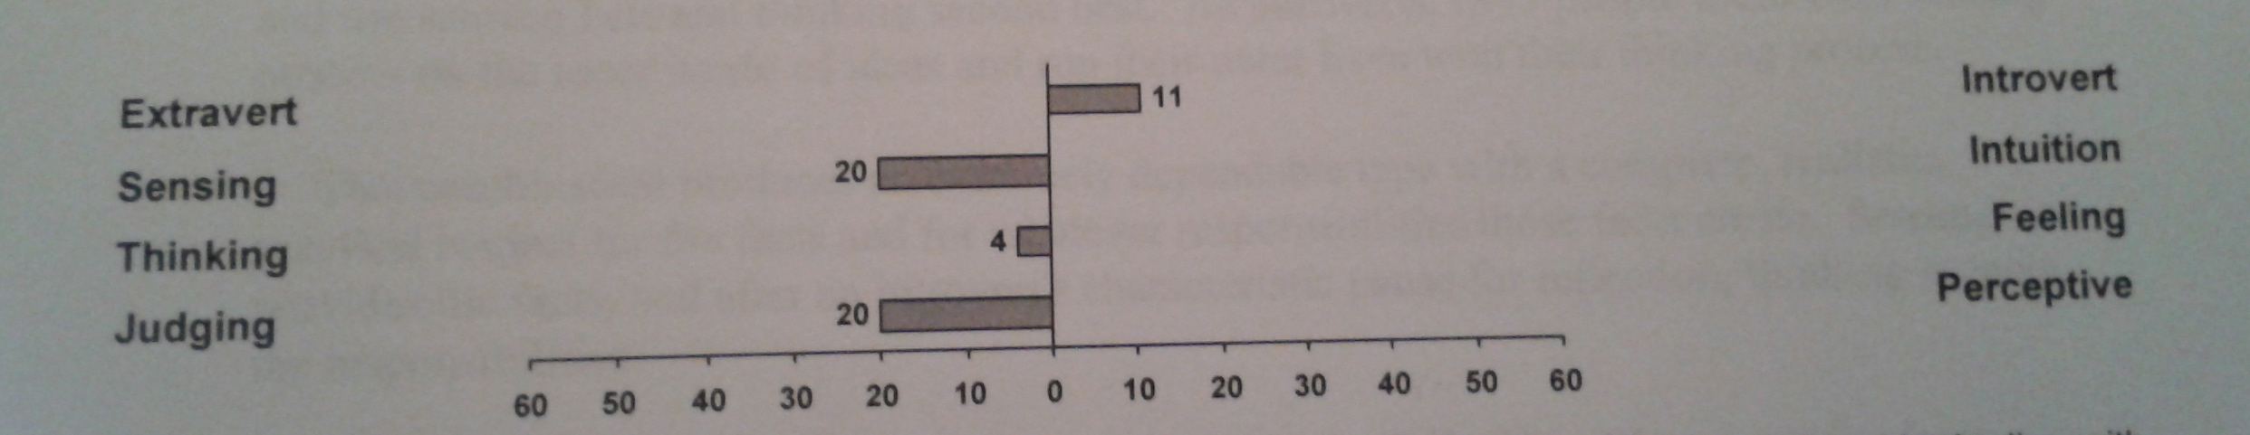
Introvert: I relate more easily to the inner world of ideas than the outer world of people and things.
Sensing: I would rather work with known facts than look for possibilities and relationships.
Thinking: I base my judgments more on impersonal logic and analysis than on personal values.
Judging: I like a planned, decided, orderly way of life rather than a flexible, spontaneous one.
Because ‘thinking’ only had a 4, as shown on the picture above, this one is not very strong. This means that I am almost indifferent between thinking and feeling.
Feeling: basing judgments more on personal values than on impersonal analysis and logic.
I think the Myers-Briggs Type Indicator was very accurate, and I recognized a lot of myself while reading the descriptions. Two of the careers that match my personality type well are manager/supervisor, and accountant. These are actually the two careers I was thinking about pursuing, and they both fit in my major (which is international business). This makes me more certain about the choice of major I have made.
Characteristics frequently associated with type ISTJ are:
- Serious
- Quiet
- Earn success by concentration and thoroughness
- Practical
- Orderly
- Matter-of-fact
- Logical
- Realistic
- Dependable
- Responsible
Introvert:
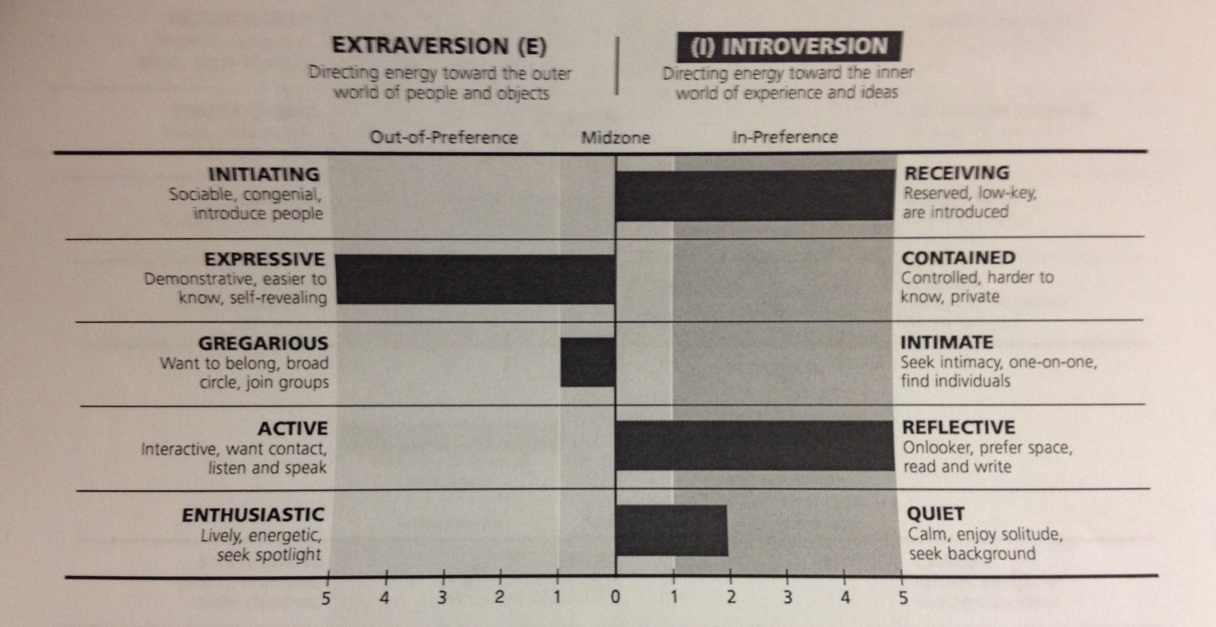

This personality trait tells me I like quiet for concentration, and I do not mind working on one project for a long time. At the tennis court while practicing I recognize that I am one of the few people that does not like it when music is playing. Introvert persons also like to think before they act, sometimes without acting. I often want to make sure I will not make mistakes or hurt people before saying something or acting. This causes me to respond slower than an extravert person.
Besides all the above-mentioned traits, and introvert person also keeps a lot of her energy inside, and I also notice that after spending time around a lot of people my energy level goes down and I need to be by myself for a while.

Sensing
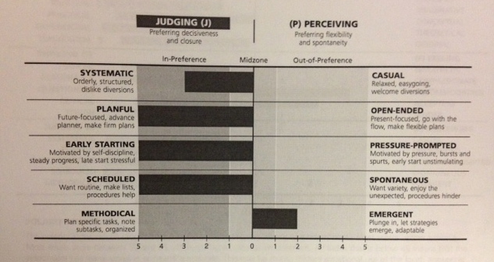

This personality trait tells me I like to use experiences and standard ways to solve problems, and I also like using developed skills more than learning new ones. These are skills that I am already confident and comfortable with, and I know what is expected of me. That is why I prefer this to learning new skills. Sensing people also seldom make errors of fact. As a sensing person, I also like evidence (facts, details, and examples) before believing statements. Also, sensing people like suggestions to be straightforward. I recognize this, because when people are straightforward I actually know what is expected of me.

Thinking
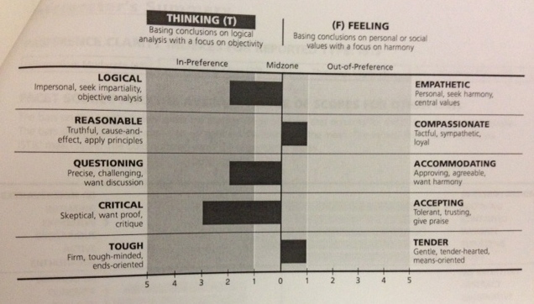
This personality trait tells me I like to use logical analysis to reach conclusions. The results also indicate that thinking people might hurt other people’s feelings without knowing it. This is something I recognize, because I am very straightforward and I sometimes do not realize my statements might hurt other people. Along with this, the results say that I can be firm-minded and can give criticism when appropriate. Next to this side of me, I also have a softer side, and this is why I am not completely on the thinking side, but somewhat in the middle section.
Finally, thinking people prefer to be brief and concise, and do not spend too many words on saying something.

Judgement

This personality trait indicates that judging people like to work scheduled, make plans, and follow the plan. These people like to get things finished, and they feel accomplished when they actually finished it. This sounds exactly like me. When a decision is made, or a project is done, I feel satisfied. When working together with other people, discussing a schedule and deadline is necessary, and during meetings we just focus on the task to be done. This personality trait also means that these people expect others to follow through and count on them.
Popular occupations for ISTJs in business
- Office Manager
- Accountant
- Auditor
- Manager/supervisor
- Word processing specialist
- Insurance underwriter
- Efficiency expert/analyst
My major is international business, and I am specializing in accounting. This means that my specialization matches my personality type.

Strengthsfinder 2.0
Strengthsfinder 2.0 is a book written by Tom Rath, which helps people identify their top 5 types of talents out of the 34 possibilities. This allows people to find out what they are good at, and use this to their advantage in their life. Rath believes it is important to develop strengths instead of correcting deficiencies. I took the online test that came with the book, and my 5 strengths turned out to be:
1. Harmony
2. Achiever
3. Competition
4. Relator
5. Analytical
In the book, Tom Rath talks about how to apply our strengths.
Harmony
With harmony, you look for areas of agreement. I do not like conflicts, and I do not feel comfortable being around conflicts. Whenever people have different views, I will try to find the common ground to eliminate the chance of conflict, because I do not like it when people dislike me. One of the benefits of always finding harmony is being able to build a network of people with differing perspectives.
Achiever
As an achiever, you constantly feel the need for achievement. Every single day I want to get the best out of myself, and I feel unsatisfied when I do not achieve something I wanted to achieve. As an achiever, a good idea for a job would be one in which I can measure my productivity, so I will feel challenged. Also, it is important for me to feel busy, but also to know when I am done with the task I am working at. Achievers do not need a lot of motivation from other, because they have a lot of self-motivation already. Finally, it is important to partner with and work together with other achievers who want to put as much work as you in it and desire the same result.
Competition
As a person that seeks competition, I am always measuring myself to others. In class, I will always try to do better than everyone else, and on the tennis court I also measure myself with my opponents; I hate losing. I make contests of many things in life, like cycling back home and knowing the lines of a movie. Although I like competition, I do not like losing, so I will only compete in contest that I can actually win. Like with being an achiever, I should participate in measurable activities.
Relator
As a relator, I pull towards relationships I am familiar with, and people that I already know. It is harder for me to meet new people, and feel comfortable around them. I like being around my close friends because they know me and I know them; what they like and dislike. In other words: I know what I can expect when I am around the people I know. For relators, it is a good idea to find a workplace where friendships are encouraged, and the workplace is not too formal.
Analytical
As an analytical person, I like data and proof of why certain ideas are true. An analytical person also wants to know how patterns affect each other. I like making decisions objectively and honest. Work that would fit well with this strength would be a job in which numbers need to be analyzed or organized.

I liked the Strengthsfinder 2.0 test, because I recognized a lot of myself in the results. I think this test was accurate, and the book that came with the test is helpful in how apply my strengths effectively.

SIGI 3 (System of Interactive Guidance and Information)
Sigi 3 is a test offered by Ball State, which helps students evaluate their values, interests, and personality, and skills. With these results, it also gives you possible career choices that would fit you.

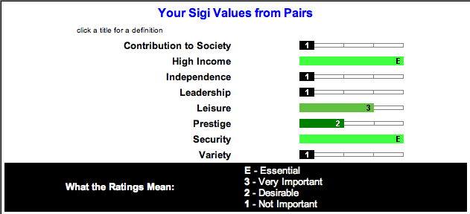
First, I took the values assessment. The test consisted of picking between two different statements which one fit me best. The results of my value assessment are visible in the figure above. My top three values are:
- High Income
- Security
- Leisure
These are the three values that are very important, or even essential to me.
Second, I took the interest assessment. The results of this test are visible on the next page.
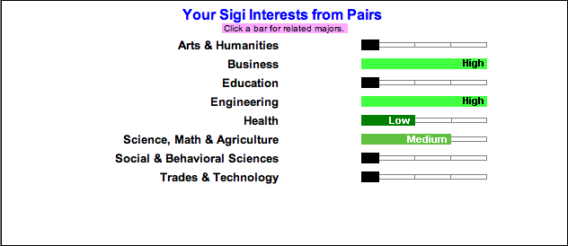

Again, the test consisted of picking between two different statements which statement fits me best. The results are shown in the figure above, and my top three in this assessment is:
- Business
- Engineering
- Science, Math, and agriculture
These results were expected, because my major is International Business, so I am interested in business, and I also like working with numbers.
Third, I took the personality assessment. This was a test that assessed my personality type by making me pick between two statements. This is another way of concentrating on what occupations would fit my needs.
My 3 personality types are:
- Conventional (most like me)
- Investigative
- Enterprising
Finally, I took the skills assessment to find out what work-related skills I have. The results are visible on the next page.

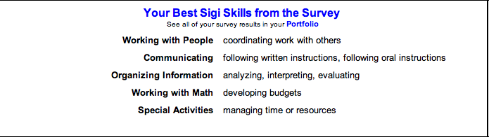

In this assessment I looked at different activities, and answered if I am “good” or “not good” at the statement provided. The results to this test, with my best skills in the different areas, are shown in the figure above. These skills all benefit in accountancy, which will be the area I am going to pick in my International Business major.
When taking the Sigi 3 test, I was not sure if the answers were going to be accurate, because I often was not sure which of the answers to pick, and the statements often seemed to be alike. After looking at the results I came to the conclusion that the test actually was accurate, and gives me a good view of my values, skills, personality, and interests. The job database that came with this test is also useful to see what jobs fit me. I think more students at Ball State should know about and use this benefit.

Personal DNA test

PersonalDNA is a test, which requires you to answer questions in different ways to determine your personality. Examples are answering questions with a scale or with a pin. The results of this test indicate that I am an independent analyst.
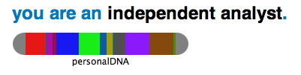
Analysts have the following characteristics:
- Attention to detail, confidence, sense of order, and focus on functionality
- Curious about how things work, delving into the mechanics behind things
- Find beauty and wonder mainly in concrete, functional, earthly things
- Very aware of your own abilities, and you believe that you will find the best way of doing things.
- Problems do not intimidate you, as you believe in yourself.
- You don't spend a lot of time imagining how things could be different—you're well-grounded in the here-and-now
- It is important for you to follow a routine, and you prefer the familiar to the unknown
- You are balanced in your approach to problem-solving, not letting your emotions hold you up

Independence has the following characteristics:
- Inward focus, trusting nature, and sharp sense of right and wrong
- Thoughts and actions are not reliant on what others think about you; you have a clearly defined moral structure.
- Very practical, expecting people to take care of themselves.
- Believe the best about people, but you hold them to high standards
- Believe in maintaining integrity, honor, and a sense of respect for those who have earned their success.
- Trust needs to be earned with you; you're slow to forgive when people have violated your trust.
- Quietly observe a lot about the world, giving you a keen sense of both how things are and how things should be.
Like all the other tests I have taken, the results to this test show similar results. The results are accurate and describe my personality, but in a little different way than previous tests did. A figure on the next page shows my personality on a scale from 0-100. This seems to be accurate, except that the confidence score is higher than I expected. In some situations I should feel more confident about myself, but in other situations I just know I can handle it. Confidence is especially an issue on the tennis court, where I sometimes think my opponent is better than me.
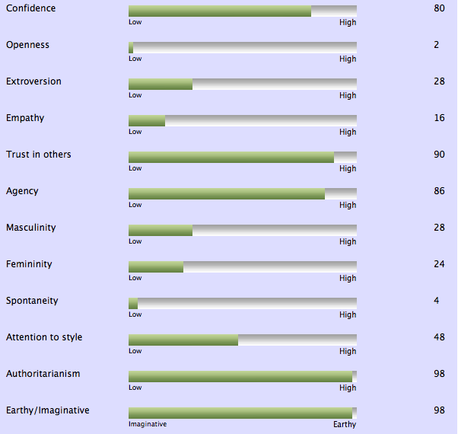

The figure above shows my personality on a scale from 0-100 on different characteristics.

The Big Five Personality test
The big five-personality test is a test that requires you to answer 45 questions with a number 1-5 (1 being strongly disagree, and 5 being strongly agree). There has been much research on how people describe others, and five major dimensions of human personality have been found. They are often referred to as the OCEAN model of personality, because of the acronym from the names of the five dimensions.
Results:
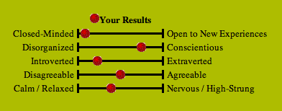

The results of the Big Five Personality test also seem to coincide with all other tests I took. Type ISTJ comes up in every test I take. To summarize the results:
- I prefer traditional and familiar experiences
- I am well-organized and reliable
- I sometimes enjoy spending quiet time on my own
- I am neither extremely forgiven, nor irritable
- I am generally a relaxed person
41 questions. 1 personality
This test consisted of 41 questions that required me to choose between two possible answers.
Your personality type: "Reliable Realist"
- Serious and quiet
- Interested in security and peaceful living
- Extremely thorough, responsible and dependable
- Well-developed powers of concentration.
- Usually interested in supporting and promoting traditions and establishments
- Well-organized and hard working
- Work steadily towards identified goals. They can usually accomplish any task once they have set their mind to it.
Careers that could fit you include:
Business executives, administrators and managers, accountants, police, detectives, judges, lawyers, medical doctors, dentists, computer programmers, systems analysts, computer specialists, auditors, electricians, math teachers, mechanical engineers, steelworkers, technicians.
Meaning results:
Extrovert – Introvert: How much I like to be around other people
Sensing – Intuitive: How I process information
Thinking – Feeling: How I make decisions
Judging – Perceiving: How I structure my life
Like the results indicate, I am an introvert person, so not as outgoing as some other people.
Also, I prefer sensing over intuitive, which means I process my information in a way that I like to know the facts.
Third, I prefer thinking to feeling; I make my decisions with my head more than with my heart.
Lastly, I prefer judging to perceiving in how I structure my life.

Feedback from employers

I currently have the privilege of coaching Kristel Sanders on the Ball State Women’s Tennis team. I recruited Kristel because I thought she was not only a great tennis player, but also a great person. Kristel balances the job duties of a student-athlete extremely well. Kristel is organized, diligent, committed, and extremely hard working. Proof of Kristel’s hard work is shown in the classroom and on the tennis court. Her skills are reflected in her grades. She is a vital player on our team. Kristel competes at #2 singles and #1 doubles. The job of a student-athlete comes with a great deal of pressure, but Kristel still excels. I also believe she is impressive because she is an international student-athlete. Kristel was born and raised in the Netherlands and was foreign to the United States prior to college. Again, a task that is difficult for many international student-athletes, Kristel handles with ease. She is an independent woman embracing change and excelling with each opportunity presented. Kristel is a joy to work with and coach.

- Christine Bader, Womens head tennis coach at Ball State University
October 2nd, 2012

Kristel has been working at our tennis camps for the past two years. Because of her passion for tennis, and my work that relates to tennis, we met each other. I have been organizing tennis camps for the past 10 years. Because Sportivity service grew out to be one of the biggest companies in this area in the Netherlands, I needed to hire more employees.
With a team of 10 people I got to know Kristel as a person that loves to work with children. She is someone that is prepared to work hard, and she likes to be directed by a supervisor to get things done. Besides this, Kristel is also prepared to be flexible.
At the tennis court also, her character as described above, becomes obvious. Kristel is a “working tennis player” and reached her current tennis level by dedicating a lot of time working hard on the court. She also likes to go deep at practices and is prepared to go deep physically.
Furthermore, Kristel is a fun and enjoyable person, but she will only show this side after working with a certain group for a while. She will wait until she feels comfortable to let loose and search for more interaction with other people.
In short: I feel like Kristel is a great addition to our team, and I think she will develop herself during the next years in our team.

- Stefan Aarts, owner of Sportivity Service in the Netherlands
October 2nd, 2012

Survey with my teammates
Next to interviewing my coach and employer, I also decided to ask my teammates to take a survey about me, because we work on and off the tennis courts together at improving ourselves. These are the 6 people that see me every day and know me best.

1) Do think I am encouraging/motivating 1 2 3 4 5
2) Do you think I am a good leader? 1 2 3 4 5
 |  |  | 2 | 4
 |  |  | 2 | 4
 |  |  | 2 | 4
 |  |  | 1 | 5
 |  |  | 2 | 4
 |  |  | 1 | 5
 |  | 1 | 4 | 1
 |  | 1 | 3 | 2
 |  |  | 3 | 3
3) Do you think I focus well on my goals? 1 2 3 4 5
4) Do you think I am dedicated? 1 2 3 4 5
5) Do you think I am organized? 1 2 3 4 5
6) Do you think I am a good team player? 1 2 3 4 5
7) Do you think I adjust well to situations 1 2 3 4 5
8) Do you think I work well with other people? 1 2 3 4 5
9) Do you think I am good at expressing myself? 1 2 3 4 5
number
1 2 3 4 5 average
Questions
1) 4.67

2) 4.67

3) 4.67

4) 4.83

5) 4.67

6) 4.83

7) 4.00

8) 4.17

9) 4.50

The numbers in the boxes indicate how many people gave me the number that is indicated above the columns. The rows stand for the number of questions. So, my teammates gave me the highest scores on questions 4 and 6, which means they think I am dedicated, and I am a good team player.
My teammates gave me the lowest scores on question 7, adjusting well to situations. This is where I could still improve, but it does match results of other tests I took; I have a harder time adjusting

I also asked all 6 of my teammates to describe me in one sentence:
- Lauren Pickrel: “Kristel is the type of person who is dedicated to her academics and her athletics. She is extremely intelligent and hard working with anything that she does. In addition, one of the nicest girls that I know”
- Bethany Moore: “You are funny, nice, and always try hard”
- Ashlyn Rang: “ You are a a fun, caring, and determined person who never gives up until she achieves the best”
- Courtney Earnest: “You are a friendly and outgoing person, as well as helpful to others and dedicated to tennis and your education”
- Dena Boulieris: “You are an amazing friend who is very funny, sweet, caring, and has a great heart”
- Courtney Wild: “You are a dedicated student, a hardworking athlete, a loving person, and you never settle for anything less than your best”

Conclusion

This first step of our project was very interesting to me. I learned about myself and recognized a lot of the results in myself. The tests were all accurate, and this surprised me because most tests consisted of less than 50 questions, which also seemed very similar. With these results I can better understand myself and use my skills and strengths to my advantage.
Hopefully this will help me find a job that fits me well, in a place where I feel comfortable working.

Bibliography

41 questions, 1 personality test. Retrieved from:
http://www.41q.com

Aarts, Stefan. Telephone interview. October 2, 2012.

Ambition test. Retrieved from:
www.queendom.com.

Bader, Christine. Personal interview. October 2, 2012.

Ball State University. Myers-Briggs Type Indicator Form Q. Assessed on February 12, 2011.

Ball State University. SIGI 3. Assessed February 10, 2011.
Strengthsfinder 2.0.

Basic personality test. Retrieved from
www.mypersonality.info.com.

Boulieris, Dena. Personal interview. October 3, 2012.

Concentration and focus skills test. Retrieved from:
http://www.queendom.com/queendom_tests/transfer.

Earnest, Courtney. Personal interview. October 3, 2012.

Moore, Bethany. Personal interview. October 2, 2012.

Pickrel, Lauren. Personal interview. October 3, 2012.

Personal DNA. Personality Test. February 21, 2011. http://www.personaldna.com.
Strengths Finder 2.0: A New and Upgraded Edition of the Online Test from Gallup's Now, Discover Your Strengths. http://www.strengthsfinder.com.
The Keirsey Temperament Sorter. Retrieved from: http://www.keirsey.com/4temps/protector.asp.

The Big Five Personality Test. Retrieved from:http://www.outofservice.com/bigfive/.

Rang, Ashlyn. Personal interview. October 3, 2012.

Wild, Courtney. Personal interview. October 3, 2012.

